Ghazian Thesis Proposal

York University, Toronto, ON

Nov. 19th, 2018

**Examining microclimatic effects on vertebrate interactions with foundational plant species.**

**Examination Committee:**

Dr. Christopher J. Lortie

Dr. Suzanne MacDonald

**Table 1. Summary** of each thesis chapter including, methods, progress, and timeline goal.

|  |  |  |  |  |
| --- | --- | --- | --- | --- |
| Chapter | Title | Methods | Progress | Timeline |
| 1 | **A systematic review of camera trap papers to test for reported sampling effort.** | Extract data for number of pictures taken, number of species seen, and location from peer-reviewed primary literature. | -Have 104 papers compiled | -Analyse data in January 2019 and have the manuscript by end of April 2019 |
| 2 | **Plant-animal interactions at a microsite level.** | Camera trap incidents of an animal near shrub for both 2017 and 2018 data in the Carrizo National Monument at 2 different sites shrub  -Paired with data loggers to record temperature and relative humidity  -Confirm animal behaviour via video trap data | -Field season 2019 Spring-Summer | -Process camera trap pictures August-October 2018  -Do the stats to explore the relationship between incidents of animal spotted versus temperature and RH |
| 3 | **Shelter effects on vertebrate animal interactions with foundation plant species.** | -Have 2 sites in Carrizo for the experiment  -Test various shelter types and examine effect on canopy temperature and animal behaviour  -Pair up shelters with camera traps | -Field season 2019 Spring-Summer  -Maybe 2020 field season | -Wrap-up thesis by September 2020 |

**Background**

For decades, individualistic and competition theories were the topics most favoured by plant ecologists. However, Bertness and Callaway’s (1994) ‘stress-gradient-hypothesis’ (SGH) of competition to facilitation switch under stressful environmental conditions sparked the interest of many for the topic. Many studies have thus focused on facilitation in harsh environments including arid ecosystems 2–4. Facilitation is defined as an interaction where one interacting species benefits whilst none are harmed 5. Although most facilitation research have focused on plant-plant interactions 6, the emergence of studies focusing on animal-shrub/plant has become more prevalent in recent years (Dalsgaard et al. 2011; Watson 2016).

At the centre of facilitation research lies the concept of foundational plant species or nurse plants, which are usually shrubs, perennials, trees or cushion plants that benefit other plant or taxa 7 through various mechanistic pathways such as seed trapping, abiotic stress amelioration, soil modification, and pollinator visitation for other plants 8 and seed trapping, herbivore protection, magnet pollination and facilitation‐mediated secondary seed dispersal for animals. In particular, shrub canopy is thought to be the most important agent of structural facilitation for animals through direct and indirect shelter and refuge effects 9,10. Hence, foundational plants serve as a great focal point for a variety of studies hoping to examine plant-plant, plant-animal, plant-plant-animal, or plant-animal-animal facilitation in a given ecosystem.

Desertification and arid region expansion are critical global change issues 11. Temperature, variability in precipitation, extended drought periods, and radiation are probable factors affecting the function of foundation species 12–14. The changes in the above weather parameters are primarily due to anthropogenic climate change 15 that significantly modifies physical and biological systems in all continents 16. Few studies have focused on the effects of anthropogenic factors on animal behaviour or the conservation of general biodiversity (Berger-Tal et al. 2016). Thus, closing this research gap by examining behavioural-ecological domains such as movement and spatial pattern, forging and vigilance, social organization, and reproductive behaviour (Berger-Tal et al. 2011) against the landscape can provide crucial knowledge for conservation paradigms and frameworks. Weather can be defined as short-term (minutes to months) changes in atmospheric conditions, while climate is the long-term weather pattern of a particular region (NASA 2005). Here we refer to weather as micro-climate. Micro-climatic-driven behavioural plasticity can promote shifts in habitat so behavioural regimes can continue to function despite changes in climate 19. Here, I propose that changes in weather parameters can alter vertebrate behaviour and hence their interactions with foundation plant species in deserts. Particularly, I’m interested in examining to what frequency and extent temperature and solar radiation can influence this interaction.

Carrizo Plain National Monument (35.1914° N, 119.7929° W) is the largest remnant ecosystem of the San Joaquin Desert located in the south-eastern San Louis Obispo Country 20. The dominant shrub species are *Ephedra californica* (Mormon tea) and *Atriplex polycarpa* (saltbush) (Stout et al. 2014). The species *E. californica* is a slow-growing shrub which spreads colonially in hot deserts (Sawyer, Keeler-Wolf, and Evens 2009). It is well-adapted to alluvial substrate and shifting sand, generally growing in elevations of 200-1200 m. Although severe fires can kill the plant (Anderson 2004), it is fairly resistant to moderate fires with the ability to sprout. Ephedra’s high abundance and resilience in this ecosystem makes it the perfect plant to study positive plant-animal interactions.

Open-top Chambers (OTC) are relatively inexpensive and provide a means to manipulate parameters such as CO2, temperature, soil temperature, solar radiation, and humidity 23,24. However, a cheaper alternative is UV-permeable Perspex shelters that can be used to increase the temperature, allow airflow, and change radiation intensity and UV permeability. To the best of our knowledge, no experiment has paired Perspex shelter designs with camera traps in order to examine the impact of manipulations of the above parameters on animal behaviour. The closest analog is animal monitoring under solar panel arrays 25, but these surveys typically include full light exclosures by the panels. Camera trapping allows researcher to obtain wildlife data with relatively little to no human disturbance (O’Connell et al. 2011; Trolliet et al. 2014). Previous studies have explored the use of cam traps to estimate population size 28, examine wildlife behaviour 29, and explore activity patterns and habitat use 30. Although camera traps have been used to look at animal interactions with plants to an extent 31, using them explore shelter effects and interactions with foundation plants is both novel and critical to better understand solar farm deployments in desert ecosystems and their use for conservation purposes.

Despite previous literature’s focus on closing the gaps that exists in photographic rates as an index of density 32,33, to my knowledge no single study to this date has been published that concentrates on generating rarefaction curves of number of images versus species richness compiled from previous research data. Rarefaction curves can gives us insight into the sampling effort required for this type of trapping in a given environment in order to accurately determine species richness- a novel gap that exists in the current literature.

**Chapter 1: A systematic review of camera traps to generate species rarefaction curves**

**Purpose:** Identify the relevant literature using camera traps to examine sampling efficacy for abundance and richness of animals with this trapping tool.

**Questions:** In which ecosystems was camera trapping done? What was the duration of sampling? How many pictures were taken? How many photos had animals in them? What were the animals (species)? How many species in reality settle in that habitat (GBIF-Global Biodiversity Information Facility)? What was the sampling area? Was the total area sampled reported? Was the camera field of view reported?

**Hypothesis:** There a few studies exploring photogenic rate as an index of density, though there is a lack of literature which has created rarefaction curves from previously published literature data-a research gap that needs more attention. These graphs can be used to estimate the abundance and richness in a given area, in addition to the number of cameras needed to be deployed for sufficient data.

**Predictions:** Many studies using camera traps focus on one type of species which makes it difficult to record species richness of a given area. Furthermore, I predict that most studies will solely report either the duration of camera trapping or the number of photos. Studies will also rarely focus on minimizing repeat visits. Thus it will be important to generate a method that is able to obtain the most amount of data from the published literature in order to generate the best estimates for sampling effort across.

**Methods:** Figure 1 represents the workflow for extracting relevant data. Literature will be obtained through keyword searches in Web of Science using a mixture of the keywords listed in the figure. Abstracts will be reviewed and all opinion, review, and idea papers will be removed so that the focus remains on actual field studies. Selected papers must contain the number of pictures taken, the number of animals spotted and which species, and the location. Preferably, latitude and longitude coordinates are also obtained from the studies, as well as sampling duration, and camera field of view.

**Preliminary Results:** Thus far, 104 papers are combined through keyword searches. Not all list the variables of interest, but most do list some combination. A closer look would determine whether enough studies provide us with key variables needed for this systematic review.

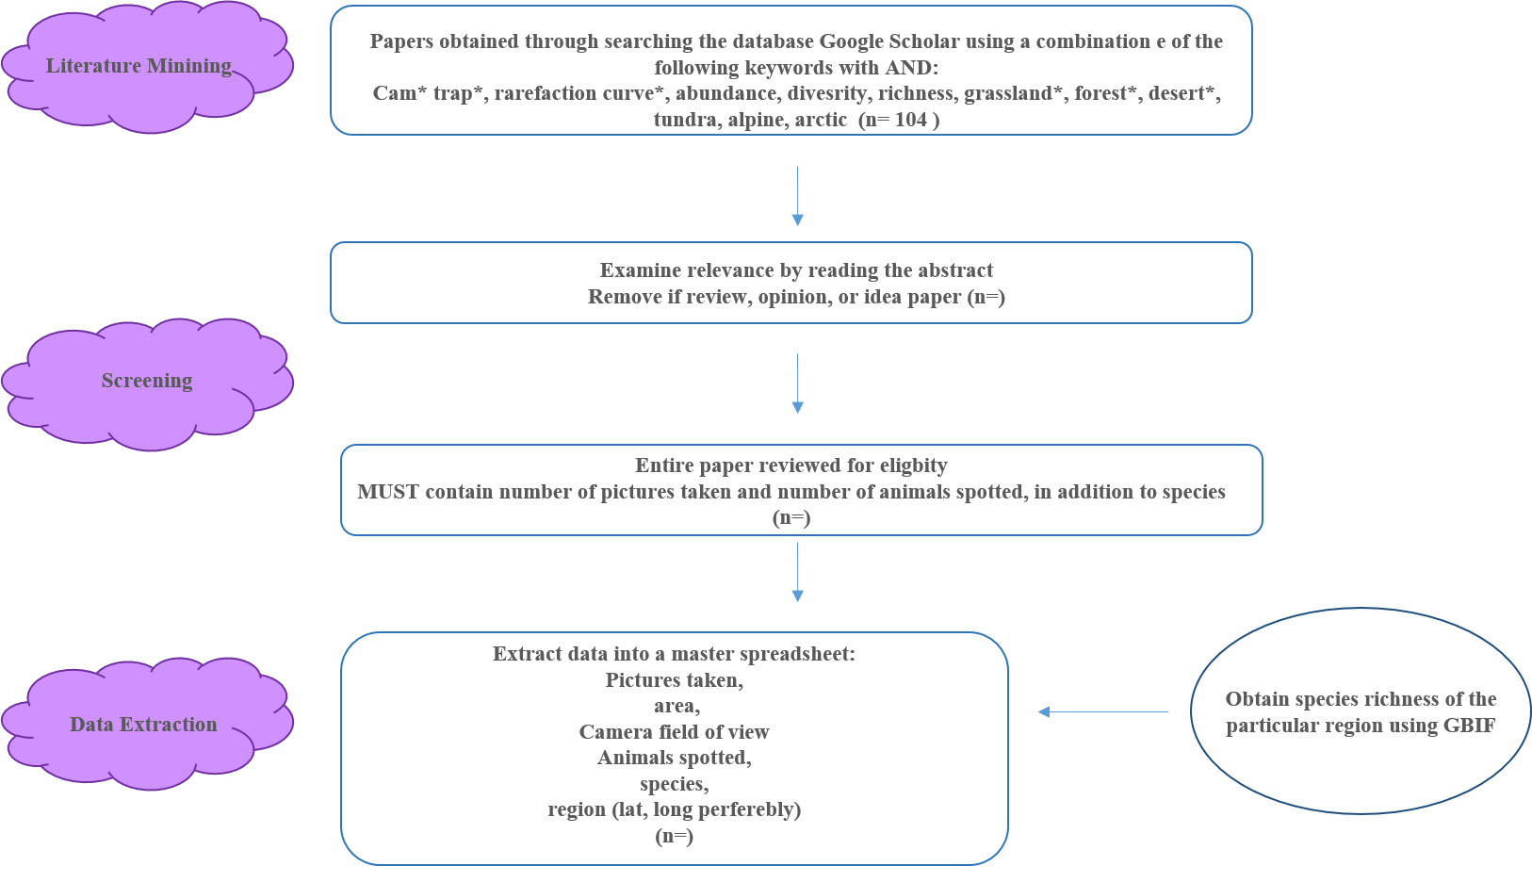

**Figure 1:** Workflow used to select the relevant literature for generating rarefaction curves from cam trap literature.

**Chapter 2: A look at the effects of temperature and relative humidity on shrub-animal interactions at a microsite level.**

**Purpose:** To explore whether animal association patterns with shrubs are explained by microsite level fluctuations in temperature and relative humidity.

**Questions:** How do temperature, soil temperature, and humidity influence the associational patterns of vertebrates with shrubs? How does the strength of this association change as the above parameters increase or decrease?

**Hypotheses and predictions:** Because shrubs are thermal refuge for many desert animal populations, as temperature increases the association for some animal species also increases such as poikilotherms

**Methods:**

**Cam trapping**

Camera trapping will be done in the Spring-Summer of 2018 in the Carrizo National Monument at 2 different sites: sites 3 and 4. Cameras will be moved around to maximize incidents of associational observation. Each camera was deployed facing a shrub with their respective open microsite camera facing the back of the shrub camera. Cameras were exactly at ground level at any given coordinate and secured using pegs. The camera will be set up exactly 3 meters from the canopy of the shrub. 2 sets of temperature loggers (one soil and one air) will be placed below the canopy for shrub microsite and 3 meters away from the camera in the open for the open microsite.

**Processing**

Images collected will be saved as Joint Photographic Expert Group (JPEG) format. These data-frames will then be manually examined for the presence of animals. A datasheet will be created where every row corresponded to a unique image. Additionally, data will be recorded for the year, region, calendar date, microsite, rep, photo rep, and week number. If a vertebrate was present in the photo, further info on the type of vertebrate, time block, actual time, temperature, and additional observations will also be recorded. An animal will be classified as present if as little as a section of a body part (i.e. tail) made it into the captured image. Because the dates and timestamps are generally wrong on these traps, dates must be manually corrected in R programming language using the match function. Behavioural data are to be obtained from video traps as a collaborative effort with Mario Zuliani-another lab member. For the most part the same parameters as above are to be recorded alongside behaviour.

**Statistics**

Point-biserial correlation analyses will be performed, examining the relationship between the continuous weather variable and the binary variable presence/absence of animal 34. Effects of covariates may be studied through an ANCOVA. Effects of multiple weather parameters may be explored through Principle Component Analysis (PCA) 35. All stats will be performed in R version 5.3.1 (R Development Core Team 2018). Data repository can be found here: <https://github.com/nargolg1/Anima-Behaviour-and-Climate-project>

**Chapter 3: Shelter experiment to manipulate micro-climatic conditions.**

**Purpose:** To physically manipulate temperature and relative humidity using various shelters types to examine how these parameters affect animal-plant shrub associational patterns.

**Hypotheses and predictions:** Foundation species, shelter, and relatively large objects in desert ecosystems influence association behaviour and population dynamics including movement. This is likely due to the benefits provided through various mechanistic pathways to the beneficiaries. Additionally, the presence of a foundational species will likely increase the soil microbiota due to the benefits provided by the plant 36.

**Methods:**

Shelters will be built in the field from UV permeable Perspex glued together (Figure 2). The presence of the shelter will result in an increase in temperature which will be measured by temperature loggers. Soil temperature and relative humidity will also be recorded via loggers. Soil microbiota samples will be taken once before the start of the study and once when the study is completed in order to be analyzed so possible microbial differences before and after can be studies. Shelter sites would be paired with simple open and shrub microsites. Furthermore, a mesh shelter that does not manipulate any weather parameters will be used as control. Shrub height, length, and width (x, y, and z) dimensions will also be recorded once before and after the study is finished for both shelter and non-shelter microsites. Open-Top-Chambers (OTC) will be built using 23) protocol; however, without the solar-heated air induction tunnel (Figure 3). The OTC will have a whole to allow the movement of animals in and out. Patio umbrellas will serve as a 3rd shelter-type. The study will take place in site 3 and 4 of Carrizo. Table 2 summarizes the treatments and replications. Camera traps will be paired with half the total replicates during the 3 week duration of the experiment.

**Stats**

Statistical analyses will examine the variance within and between groups for the parameters to be tested.

**Table 2.**  **Replication** breakdown for open-shrub microsites and shelters.

|  |  |  |  |
| --- | --- | --- | --- |
| **Microsite** | **Shelter** | **Replication** | **Total** |
| **X2** | **X4** | **X3** | **24** |
| **Shrub** | **UV permeable Perspex** |
| **Open** | **OTC** |
|  | **Mesh** |

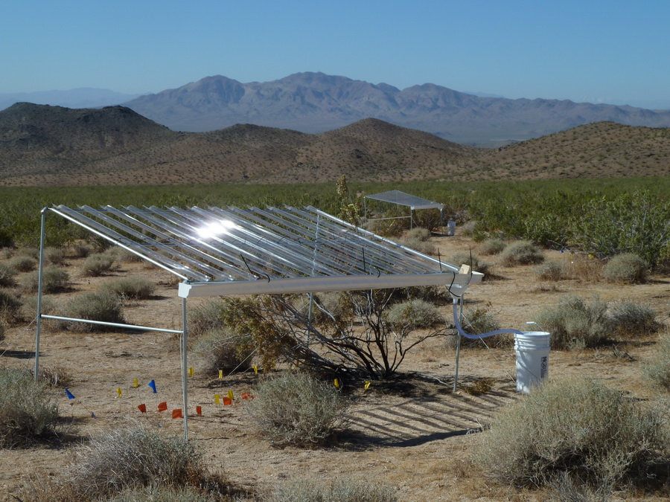

**Figure 2:** Perspex shelters to be built will be similar to the above design; though, two of the sides will also most likely be covered with Perspex and metal bars will not be used

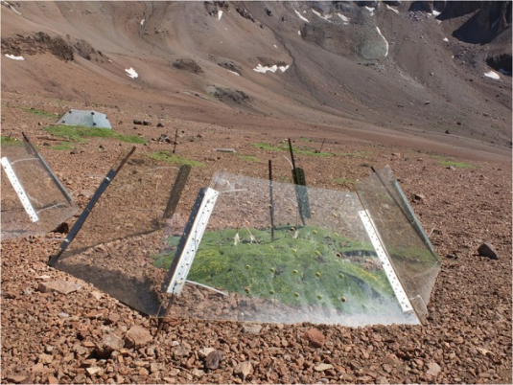

**Figure 3:** OTC shelter design (Google images).

**References**

1. Bertness, M. D. & Callaway, R. Positive interactions in communities. *Trends Ecol. Evol.* **9**, 191–193 (1994).

2. Maestre, F. T., Callaway, R. M., Valladares, F. & Lortie, C. J. Refining the stress-gradient hypothesis for competition and facilitation in plant communities. *J. Ecol.* **97**, 199–205 (2009).

3. Michalet, R., Le Bagousse-Pinguet, Y., Maalouf, J.-P. & Lortie, C. J. Two alternatives to the stress-gradient hypothesis at the edge of life: the collapse of facilitation and the switch from facilitation to competition. *J. Veg. Sci.* **25**, 609–613 (2014).

4. Lu, R. *et al.* Nurse effects of patch-canopy microhabitats promote herbs community establishment in sandy land. *Ecol. Eng.* **118**, 126–133 (2018).

5. Bertness, M. D. & Leonard, G. H. THE ROLE OF POSITIVE INTERACTIONS IN COMMUNITIES: LESSONS FROM INTERTIDAL HABITATS. *Ecology* **78**, 1976–1989 (1997).

6. Lortie, C. J., Filazzola, A. & Sotomayor, D. A. Functional assessment of animal interactions with shrub-facilitation complexes: a formal synthesis and conceptual framework. *Funct. Ecol.* **30**, 41–51 (2016).

7. Gómez-Aparicio, L. *et al.* APPLYING PLANT FACILITATION TO FOREST RESTORATION: A META-ANALYSIS OF THE USE OF SHRUBS AS NURSE PLANTS. *Ecol. Appl.* **14**, 1128–1138 (2004).

8. Filazzola, A. & Lortie, C. J. A systematic review and conceptual framework for the mechanistic pathways of nurse plants: A systematic review of nurse-plant mechanisms. *Glob. Ecol. Biogeogr.* **23**, 1335–1345 (2014).

9. Bråthen, K. A. & Lortie, C. A portfolio effect of shrub canopy height on species richness in both stressful and competitive environments. *Funct. Ecol.* **30**, 60–69 (2016).

10. Lortie, C. J., Gruber, E., Filazzola, A., Noble, T. & Westphal, M. The Groot Effect: Plant facilitation and desert shrub regrowth following extensive damage. *Ecol. Evol.* **8**, 706–715 (2018).

11. Asner, G. P. & Heidebrecht, K. B. Desertification alters regional ecosystem-climate interactions. *Glob. Change Biol.* **11**, 182–194 (2005).

12. Kogan, F. & Guo, W. 2006–2015 mega-drought in the western USA and its monitoring from space data. *Geomat. Nat. Hazards Risk* **6**, 651–668 (2015).

13. MacDonald, G. M. Severe and sustained drought in southern California and the West: Present conditions and insights from the past on causes and impacts. *Quat. Int.* **173**–**174**, 87–100 (2007).

14. Tattini, M. *et al.* Morpho-anatomical, physiological and biochemical adjustments in response to root zone salinity stress and high solar radiation in two Mediterranean evergreen shrubs, Myrtus communis and Pistacia lentiscus. *New Phytol.* **170**, 779–794 (2006).

15. Gibelin, A.-L. & Déqué, M. Anthropogenic climate change over the Mediterranean region simulated by a global variable resolution model. *Clim. Dyn.* **20**, 327–339 (2003).

16. Rosenzweig, C. *et al.* Attributing physical and biological impacts to anthropogenic climate change. *Nature* **453**, 353 (2008).

17. Berger-Tal, O. *et al.* A systematic survey of the integration of animal behavior into conservation: Animal Behavior and Conservation. *Conserv. Biol.* **30**, 744–753 (2016).

18. Berger-Tal, O. *et al.* Integrating animal behavior and conservation biology: a conceptual framework. *Behav. Ecol.* **22**, 236–239 (2011).

19. Noonan, M. J. *et al.* In situ behavioral plasticity as compensation for weather variability: implications for future climate change. *Clim. Change* **149**, 457–471 (2018).

20. Noble, T. J., Lortie, C. J., Westphal, M. & Butterfield, H. S. A picture is worth a thousand data points: an imagery dataset of paired shrub-open microsites within the Carrizo Plain National Monument. *GigaScience* **5**, (2016).

21. Deborah Stout, Jennifer Buck-Diaz, Sara Taylor & Julie M. Evens. *Vegetation mapping and accuracy assessment report for Carrizo Plain National Monument. California Native Plants Society.* (2014).

22. Michelle D. Anderson. *Ephedra nevadensis. In: Fire Effects Information System*. (U.S. Department of Agriculture, Forest Service, Rocky Mountain Research Station, Fire Sciences Laboratory, 2004).

23. Chiba, M. & Terao, T. Open-Top Chambers with Solar-Heated Air Introduction Tunnels for the High-Temperature Treatment of Paddy Fields. *Plant Prod. Sci.* **17**, 152–165 (2014).

24. Welshofer, K. B., Zarnetske, P. L., Lany, N. K. & Thompson, L. A. E. Open-top chambers for temperature manipulation in taller-stature plant communities. *Methods Ecol. Evol.* **9**, 254–259 (2018).

25. Wilhelm, J., Blackshire, S. & Lanzone, M. Energy-Neutral Data Collection Rate Control for IoT Animal Behavior Monitors. *Appl. Sci.* **7**, 1169 (2017).

26. *Camera Traps in Animal Ecology*. (Springer Japan, 2011). doi:10.1007/978-4-431-99495-4

27. Trolliet, F., Huynen, M.-C., Vermeulen, C. & Hambuckers, A. Use of camera traps for wildlife studies. A review. *Biotechnol Agron Soc Env.* 9 (2014).

28. Karanth, K. U. Estimating tiger Panthera tigris populations from camera-trap data using capture—recapture models. *Biol. Conserv.* **71**, 333–338 (1995).

29. Dupuis-Desormeaux, M. *et al.* Testing the Prey-Trap Hypothesis at Two Wildlife Conservancies in Kenya. *PLOS ONE* **10**, e0139537 (2015).

30. Bowkett, A. E., Rovero, F. & Marshall, A. R. The use of camera-trap data to model habitat use by antelope species in the Udzungwa Mountain forests, Tanzania. *Afr. J. Ecol.* **46**, 479–487 (2008).

31. Paviolo, A. *et al.* Barriers, corridors or suitable habitat? Effect of monoculture tree plantations on the habitat use and prey availability for jaguars and pumas in the Atlantic Forest. *For. Ecol. Manag.* **430**, 576–586 (2018).

32. Carbone, C. *et al.* The use of photographic rates to estimate densities of tigers and other cryptic mammals. *Anim. Conserv.* **4**, 75–79 (2001).

33. Rovero, F. & Marshall, A. R. Camera trapping photographic rate as an index of density in forest ungulates. *J. Appl. Ecol.* **46**, 1011–1017 (2009).

34. Gupta, S. D. Point biserial correlation coefficient and its generalization. *Psychometrika* **25**, 393–408 (1960).

35. Bryant, F. B. & Yarnold, P. R. Principal-components analysis and exploratory and confirmatory factor analysis. in *Reading and understanding multivariate statistics.* 99–136 (American Psychological Association, 1995).

36. Bodelier, P. L. E., Stomp, M., Santamaria, L., Klaassen, M. & Laanbroek, H. J. Animal–plant–microbe interactions: direct and indirect effects of swan foraging behaviour modulate methane cycling in temperate shallow wetlands. *Oecologia* **149**, 233–244 (2006).